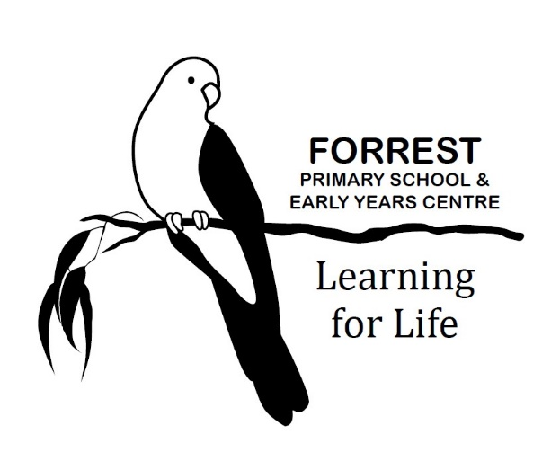
VOLUNTEERS POLICY

Purpose
To outline the processes that Forrest Primary School will follow to recruit, screen, supervise and manage volunteers to provide a child safe environment, and to explain the legal rights of volunteers.

Scope
This policy applies to the recruitment, screening, supervision, and management of all people who volunteer at our school.

Definitions
Child-related work: work that usually involves direct contact (including in person, over the phone, written and online communication) with a child that is a central part of that person’s duties. It does not include work that involves occasional contact with children that is incidental to the work.
Closely related family member: parent, carer, parent/carer’s spouse or domestic partner, stepparent, parent/carer’s mother or father in-law, grandparent, uncle or aunt, brother, or sister, including step or half siblings.
Volunteer worker: A volunteer school worker is a person who voluntarily engages in schoolwork or approved community work without payment or reward.
School work: School work means:
- Carrying out the functions of a school council
- Any activity carried out for the welfare of a school, by the school council, any parents’ club or association or any other body organised to promote the welfare of the school
- Any activity carried out for the welfare of the school at the request of the principal or school council
- Providing assistance in the work of any school or kindergarten
- Attending meetings in relation to government schools convened by any organisation which receives government financial support
This is a broad definition and means that volunteers who participate in school community activities, such as fundraising and assisting with excursions, are legally protected (ie indemnified) from action by others in the event of an injury or accident whilst they are performing volunteer school work in good faith.

Policy
Forrest Primary School is committed to implementing and following practices which protect the safety and wellbeing of children and our staff and volunteers. Forrest Primary School recognises the valuable contribution that volunteers provide to our school community and the work that we do.
The procedures set out below are designed to ensure that Forrest Primary School’s volunteers are suitable to work with children and are well-placed to make a positive contribution to our school community.

Becoming a volunteer
On occasion Forrest Primary School will ask for volunteers to assist with a specific event. Members of our school community who would like to volunteer are encouraged to contact the Principal or approach the classroom teacher to enquire about volunteering.

Suitability checks including Working with Children Checks
Working with students
Forrest Primary School values the many volunteers that assist in our classrooms, with sports events, camps, excursions, school concerts and other events and programs. To ensure that we are meeting our legal obligations under the Working With Children Act 2005 (Vic) and the Child Safe Standards, Forrest Primary School is required to undertake suitability checks which may include a Working With Children Check, proof of identity, work history involving children and/or reference checks.
Considering our legal obligations, and our commitment to ensuring that Forrest Primary School is a child safe environment, we will require volunteers to obtain a WWC Check and produce their valid card to staff in the School Office for verification in the following circumstances:
- Volunteers who are not parent/family members of any student at the school are required to have a WWC Check if they are engaged in child-related work regardless of whether they are being supervised.
- Parent/family volunteers who are assisting with any classroom or school activities involving direct contact with children in circumstances where the volunteer’s child is not participating, or does not ordinarily participate in, the activity.
- Parent/community School Council members sitting on School Council with student School Council members, regardless of whether their own child is a student member or not

In addition, depending on the nature of the volunteer work, our school may ask the volunteer to provide other suitability checks at its discretion (for example, references, work history involving children and/or qualifications). Proof of identity may also be required in some circumstances.
Non-child-related work
On some occasions, parents and other members of the school community may volunteer to do work that is not child related. For example, maintenance, working bees, school council, participating in sub-committees of school council, other fundraising groups that meet in the evenings during which children will not be, or would not reasonably be expected to be, present.
Volunteers for this type of work are not required to have Working with Children or other suitability checks as they are not engaged in child-related work and children are not generally present during these activities. However, Forrest Primary School reserves the right to undertake suitability checks, including proof of identity, Working with Children Checks, at its discretion if considered necessary for particular activities or circumstances.
Training and induction
Under the Child Safe Standards volunteers must have an appropriate induction and training in child safety and wellbeing.
To support us to maintain a child safe environment, before engaging in any work where children are present or reasonably likely to be present, volunteers must familiarise themselves with the policies, procedures and code of conduct referred to in our Child Safety Induction Pack and ensure the actions and requirements in these documents are followed when volunteering for our school.
Depending on the nature and responsibilities of their role, Forrest Primary School may also require volunteers to complete additional child safety training.

Management and supervision
Volunteer workers will be expected to comply with any reasonable direction of the principal (or their nominee). This will include the requirement to follow our school’s policies, including, but not limited to our Child Safety Policy and our Child Safety Code of Conduct.
Volunteer workers will also be expected to act consistently with Department of Education policies, to the extent that they apply to volunteer workers, including the Department’s policies relating to Equal Opportunity and Anti-Discrimination, Sexual Harassment and Workplace Bullying.
The principal (or their nominee) will determine the level of school staff supervision required for volunteers, depending on the type of work being performed, and with a focus on ensuring the safety and wellbeing of students.
The principal has the discretion to make a decision about the ongoing suitability of a volunteer worker and may determine at any time whether or not a person is suitable to volunteer at Forrest Primary School.

Privacy and information-sharing
Volunteers must ensure that any student information they become aware of because of their volunteer work is managed sensitively and in accordance with the Schools’ Privacy Policy and the Department’s policy on Privacy and Information Sharing.
Under these policies, student information can and should be shared with relevant school staff to:
- support the student’s education, wellbeing and health;
- reduce the risk of reasonably foreseeable harm to the student, other students, staff or visitors;
- make reasonable adjustments to accommodate the student’s disability; or
- provide a safe and secure workplace.
Volunteers must immediately report any child safety concerns that they become aware of to a member of staff to ensure appropriate action. There are some circumstances where volunteers may also be obliged to disclose information to authorities outside of the school such as to Victoria Police. For further information on child safety responding and reporting obligations refer to: Child Safety Responding and Reporting Obligations Policy and Procedures.

Records management

While it is unlikely volunteers will be responsible for any school records during their volunteer work, any school records that volunteers are responsible for must be provided to Sarah Lane to ensure they are managed in accordance with the Department’s policy: Records Management – Schools.

Compensation
Personal injury
Volunteer workers are covered by the Department of Education and Training’s Workers Compensation Policy if they suffer personal injury in the course of engaging in school work.
Property damage
If a volunteer worker suffers damage to their property in the course of carrying out school work, the Minister (or delegate) may authorise such compensation as they consider reasonable in the circumstances. Claims of this nature should be directed to the principal who will direct them to the Department’s Legal Division.
Public liability insurance
The Department of Education and Training’s public liability insurance policy applies when a volunteer worker engaged in school work is legally liable for:
- a claim for bodily injury to a third party
- damage to or the destruction of a third party’s property.

FURTHER INFORMATION and resources

This policy should be read in conjunction with the following policies on the Department’s Policy and Advisory Library (PAL):
- Equal Opportunity and Anti-Discrimination
- Child Safe Standards
- Privacy and Information Sharing
- Records Management – School Records
- Sexual Harassment
- Volunteers in Schools
- Volunteer OHS Management
- Working with Children and Other Suitability Checks for School Volunteers and Visitors
- Workplace Bullying

Related policies and resources
Forrest Primary School policies and resources relevant to this policy include:
- Statement of Values and School Philosophy
- Visitors Policy
- Child Safety and Wellbeing Policy
- Child Safety Code of Conduct
- Child Safety Responding and Reporting Obligations Policy and Procedures
- Inclusion and Diversity Policy
Department policies:
- Equal Opportunity and Anti-Discrimination
- Child Safe Standards
- Privacy and Information Sharing
- Records Management – School Records
- Sexual Harassment
- Volunteers in Schools
- Volunteer OHS Management
- Working with Children and Other Suitability Checks for School Volunteers and Visitors
- Workplace Bullying

Policy REVIEW and Approval
Policy last reviewed | March 2025
Consultation | School Council
Approved by | Principal
Next scheduled review date | March 2027

