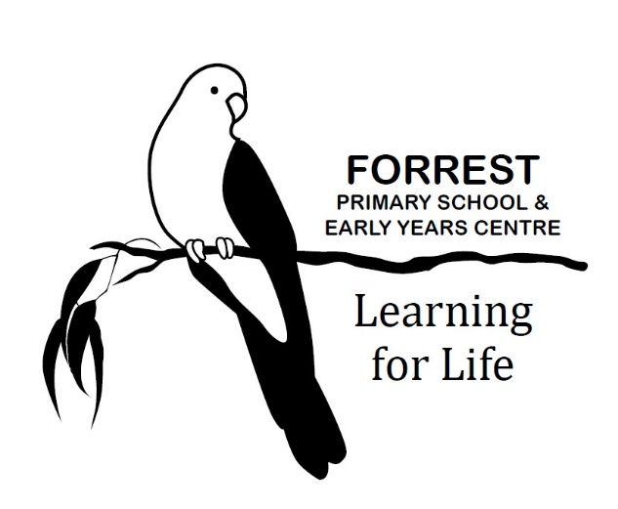
CAMPS AND EXCURSIONS

Purpose
To explain to our school community the processes and procedures Forrest Primary School will use when planning and conducting camps, excursions and adventure activities for students.

Scope
This policy applies to all camps and excursions organised by Forrest Primary School. This policy also applies to adventure activities organised by Forrest Primary School, regardless of whether or not they take place on or off school grounds, and to school sleep-overs.
This policy is intended to complement the Department’s policy and guidelines on excursions, camps and adventure activities which all Victorian government schools are required to follow. Forrest Primary School will follow both this policy, as well as the Department’s policy and guidelines when planning for and conducting camps and excursions.
This policy does not apply to student workplace learning or intercampus travel.

Definitions
Excursions:
For the purpose of this policy, excursions are activities organised by the school where the students:
- are taken out of the school grounds (for example, a camp, day excursion, school sports);
- undertake adventure activities, regardless of whether or not they occur outside the school grounds;
- Attend school ‘sleep-overs’ on school grounds
Camps are excursions involving at least one night’s accommodation (including school sleep-overs).
Local excursions are excursions to locations within walking distance of the school and do not involve ‘Adventure Activities’.
Adventure activities are activities that involve a greater than normal risk. Further information and examples of adventure activities are available on the Department’s Policy and Advisory Library, at the following link:
https://www2.education.vic.gov.au/pal/excursions/guidance/adventure-activities

Policy
Camps and excursions can provide a valuable educational experience for our students which are complementary to their learning, as they provide access to resources, environments and expertise that may not be available in the classroom.
For all camps and excursions, including adventure activities, our school will follow the Department’s Policy and Advisory Library: Excursions.

Planning process for camps and excursions
All camps and excursions will comply with Department planning requirements.
Part of this planning process includes conducting risk assessments, to ensure that reasonable steps are taken to minimise the risks associated with each proposed camp or excursion. Forrest Primary School’s risk assessment will include consideration of arrangements for supervision of students and consideration of the risk of bushfire activity in the excursion location. In the event of a Code Red Day being announced, excursions or camp activities in effected locations will be cancelled or rescheduled. Planning will also cover arrangements for cancelling, recalling or altering the camp or excursion for any other reason.
Forrest Primary School is committed to ensuring students with additional needs are provided with an inclusive camps and excursions program and will work with families during the planning stage, as needed, to support all students’ attendance and participation in camp and excursion activities.
In cases where a camp or excursion involves a particular class or year level group, the Organising Teacher will ensure that there is an alternative educational program available and appropriate supervision for those students not attending the camp or excursion.

Supervision
Forrest Primary School follows the Department’s guidelines in relation to supervision of students during excursions and camps.
All excursion staff (including parent volunteers) will be familiar with supervision requirements and the specific procedures for dealing with emergencies on each camp and excursion.
All school staff will be aware that they retain overall responsibility for the supervision and care of students throughout all camps and excursions (including adventure activities), regardless of whether or not external providers are managing the activity.

Parent volunteers
Parents may be invited to assist with camps and excursions. School staff will notify parents/carers of any costs associated with attending. School staff are in charge of camps and excursions and parent/carer volunteers are expected to follow teachers' instructions. When deciding which parents/carers will attend, the Organising Teacher will take into account: any valuable skills the parents/carers have to offer (e.g. bus licence, first aid etc.) and the special needs of particular students.
Volunteer and external provider checks
Forrest Primary School requires all camp or excursion volunteers and all external providers working directly with our students to have a current Working with Children Check card.

Parent/carer consent
For all camps and excursions, other than local excursions, Forrest Primary School will provide parents/carers with a specific consent form outlining the details of the proposed activity. Forrest Primary School uses Compass to inform parents about camps and excursions and to seek their consent. Parents/carers are encouraged to contact the school to discuss any questions or concerns that they or their child may have with a proposed camp or excursion.
For local excursions, Forrest Primary School will provide parents and carers with an annual Local Excursions consent form at the start of each school year or upon enrolment if students enrol during the school year. Forrest Primary School will also provide advance notice to parents/carers of an upcoming local excursion through Compass or a note home in the student’s bag. For local excursions that occur on a recurring basis (for example weekly outings to the local oval for sports lessons), Forrest Primary School will notify parents once only prior to the commencement of the recurring event.

Cost of camps and excursions, refunds and support
The cost of all camps and excursions are to be paid by parents/carers unless alternative arrangements have been agreed to by the Principal prior to the excursion. All families will be given sufficient time to make payments for all activities. Consent forms will have clearly stated payment amounts and payment finalisation dates.
Forrest Primary School will make all efforts to ensure that students are not excluded for financial reasons. Families experiencing financial difficulty are invited to discuss alternative payment arrangements with the Business Manager. The Business Manager can also discuss family eligibility for the Department’s Camps, Sports and Excursions Fund (CSEF), which provides payments for eligible students to attend school activities, including camps and excursions. Applications for the CSEF are open to families holding a valid means-tested concession card or temporary foster parents and are facilitated by the school. Further information about the CSEF and the application form are available at Camps, Sports and Excursions Fund.
If a camp or excursion is cancelled or altered by the school, or a student is no longer able to attend part or all of the camp or excursion, our school will consider requests for partial or full refunds of payments made by parents/carers on a case-by-case basis taking into account the individual circumstances. Generally we will not be able to refund payments made for costs that have already been paid where those funds have already been transferred or committed to a third party and no refund is available to the school. Where possible, we will provide information about refunds to parents/carers at the time of payment.
Student health
Parents and carers need to ensure the school has up-to-date student health information prior to camps and excursions. A member of staff will be appointed with responsibility for the health needs of the students for each camp/excursion. Teachers will administer any medication provided according to our Medication policy and the student’s signed Medication Authority Form. To meet the school’s obligations relating to safety, a first aid kit and mobile phone will be taken by teachers on all camps and excursions.
It is the responsibility of parents and carers to ensure their child/children are in good health when attending excursions and camps. If a student becomes ill during a camp and is not able to continue at camp it is the parent/carer’s responsibility to collect them and cover any associated costs. If the Principal approves a student joining a camp late, transport to the camp is the parent/carer’s responsibility.

Behaviour expectations
Students participating in camps and excursions are required to cooperate and display appropriate behaviour to ensure the camp or excursion is a safe, positive and educational experience for all students involved.
Parents/carers will be notified if their child is in danger of losing the privilege to participate in an excursion or camp due to behaviour that does not meet the standards of behaviour set out in the school’s Student Wellbeing and Engagement Policy . The decision to exclude a student will be made by the Principal, in consultation with the Organising Teacher. Both the parent/carer and the student will be informed of this decision prior to the camp or excursion.
If on a camp or excursion the Teacher in Charge considers an individual student's behaviour does not meet required standards, then the Principal may determine that a student should return home during the camp or excursion. In these circumstances the parent/carer is responsible for the collection of the student and any costs associated with this.
Disciplinary measures apply to students on camps and excursions consistent with our school’s Student Wellbeing and Engagement Policy and Bullying Prevention Policy.

Electronic Devices
Students will not be permitted to bring electronic devices to camps or excursions except with prior approval from the Principal. The Principal will only approve students bringing electronic devices to a camp or excursion in exceptional circumstances and when it is in the best interests of the student, and may place conditions on its location and use during the camp or excursion.

Food
Students are not permitted to bring their own supply of food items to camps and excursions unless the item is medically indicated and discussed with the Organising Teacher, or included as an item on the clothing and equipment list for that camp or excursion.

Accident and Ambulance Cover

Any costs associated with student injury rest with parents/carers unless the Department is liable in negligence (liability is not automatic).
Unless otherwise indicated, Forrest Primary School and the Department do not provide student accident or ambulance cover. Parents/carers may wish to obtain student accident insurance cover and/or ambulance cover, depending on their health insurance arrangements and any other personal considerations.
COMMUNICATION
This policy will be communicated to our school community in the following way:
- Included in staff induction processes and staff training
- Available publicly on our school’s website
- Included in staff handbook/manual
- Discussed at staff briefings/meetings as required
- Reminders in our school newsletter
- Hard copy available from school administration upon request

Further information and resources
This policy should be read in conjunction with the following Department polices and guidelines:
- Excursions
- Camps, Sports and Excursions Fund
The following school policies are also relevant to this Camps and Excursions Policy:
- Statement of Values and School Philosophy
- Student Wellbeing and Engagement Policy
- Volunteer Policy
- Duty of Care Policy
- Parent Payment Policy
POLICY REVIEW AND APPROVAL
Policy last reviewed | September 2021
Approved by | Principal
Next scheduled review date | September 2025

